OVO awarded £300,000 grant
to create a new theatre in St Albans

25th September 2023

St Albans-based theatre company, OVO, has been awarded a £300,000 grant from the government’s Community Ownership Fund to create a new theatre in the city. The £150 million Community Ownership Fund has been set up over four years to help communities in England, Scotland, Wales, and Northern Ireland to take ownership of assets and amenities at risk of closure.
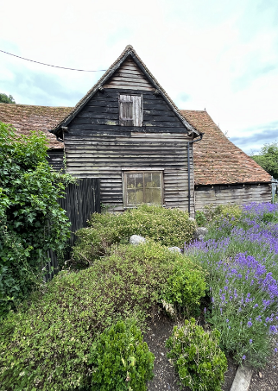
The grant will enable OVO to renovate and convert the derelict 18th century St Germain’s Barn and the adjacent disused sports pavilion, St Michael’s Changing Rooms, into an atmospheric performance space. The building will also be available for a multitude of local community uses. Both buildings are owned by St Albans City and District Council and are adjacent to the Verulamium Museum in St Albans.

The new theatre will be located within the scheduled ancient monument of Roman Verulamium, close to the Roman Theatre of St Albans, where OVO has been running its hugely successful Roman Theatre Open Air Festival since 2014.

(Site photos left and below courtesy OVO)

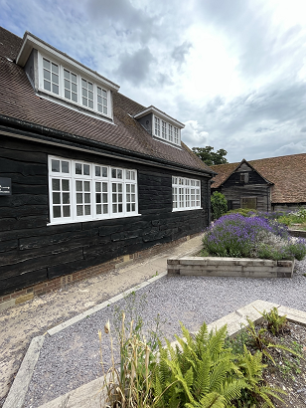
OVO’s Artistic Director, Adam Nichols (left, photo by Tim Morozzo) commented:
“We are absolutely thrilled to have been awarded this grant from the Community Ownership Fund. Our new theatre will provide a winter home for OVO, just a stone’s throw from the Roman Theatre where we have built a loyal audience over the past nine years. It will enable us to realise our long-term dream of creating a permanent repertory company and attracting the brightest and best theatre performers and creatives to our wonderful city. The beautiful St Germain’s Barn will make an intimate and atmospheric setting for bold and imaginative theatre, whilst the conversion of St Michael’s Changing Rooms will provide a fantastic place for our audiences to eat, drink and mingle and great rehearsal and backstage spaces for our performers and creatives.”

OVO aims to complete the conversion of the buildings by the end of 2024, with the new theatre opening in 2025. www.ovo.org.uk

